DEPARTMENT E
EMBROIDERY
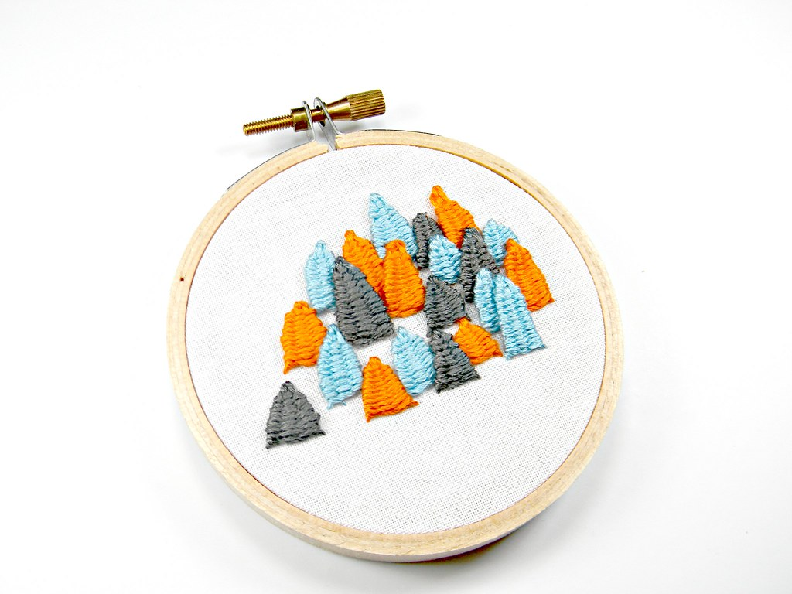
SUPERINTENDENT: Shirlee Martsch
Premiums: 1st: $2.00 2nd: $1.50 3rd: $1.00
Entry: Monday, from 9 am to 6 pm
Judged: Tuesday, from 8 am till finished
Released: Sunday, from 10 am till 2 pm
Monday, from 1 pm to 6 pm
Age Divisions:
Seniors: 65+ years (Put SR. on entry tag)
Adults: 17- 64 years
Juniors: 16 years and younger (Put JR. on entry tag)
Standards for Embroidery:
- Quality of design, interesting materials and quality of craftsmanship are important.
- Stitches should be even and regular. The selection of thread should be keyed to the type and weight of fabric and appropriate for the design. Stitches should not cause puckering. Tracing of design outlines should not be noticeable.
- An object made from a fabric on which a stitchery design has been worked or an already constructed article which has been decorated with stitchery should be well constructed and suitably presented cleaned and framed.
- Knots should not appear on the wrong side, threads should not be carried along the back
- Sizes For Embroidered Picture (These measurements are the size of the picture only):
- Small: 5” by 7” or smaller
- Medium: 5” by 8” to 11” by 14”
- Large Anything larger than 11” by 14”

DIVISION: STAMPED EMBROIDERY
CLASS NO.

- Pillowcases (pair)
- Tea Towels (set)
- Pillow
- Dresser Scarf
- Tablecloth
- Napkins/Placemats
- Apron
- Clothing
- Pictures
- Quilt Top
- Other Item

DIVISION: COUNTED EMBROIDERY
CLASS NO.

- Pillowcases (pair)
- Tea Towels (set)
- Pillow
- Clothing
- Quilt Top
- Picture, Large
- Picture, Medium
- Picture, Small
- Sampler, Large
- Sampler, Medium
- Sampler, Small
- Wall-hanging, Lrg
- Wall-hanging, Med
- Wall-hanging, Sm
- Other Item

DIVISION: STAMPED CROSS STITCH
CLASS NO.

- Pillowcases (pair)
- Tea Towels (set)
- Pillow
- Dresser Scarf
- Tablecloth
- Napkins/Placemats
- Apron
- Clothing
- Pictures
- Quilt Top
- Other Item (not listed above)

DIVISION: PULLED & CUT EMBROIDERY
CLASS NO.

- Pillowcases (pair)
- Pillow
- Dresser Scarf
- Tablecloth
- Clothing
- Quilt Top
- Other Item (not listed above)

DIVISION: MACHINE EMBROIDERY
CLASS NO.

- Pillowcases (pair)
- Tea Towels (set)
- Pillow
- Dresser Scarf
- Tablecloth
- Napkins/Placemats
- Apron
- Clothing
- Pictures
- Quilt Top
- Other Item

DIVISION: CREWEL EMBROIDERY
CLASS NO.

- Pillow
- Picture (large)
- Picture (medium)
- Picture (small)
- Other Item

DIVISION: PAINT EMBROIDERY
CLASS NO.

- Pillowcases (pair)
- Tea Towels (set)
- Pillow
- Dresser Scarf
- Tablecloth
- Napkins/Placemats
- Apron
- Clothing
- Pictures
- Quilt Top
- Other Item

DIVISION: APPLIQUE DIVISION
DIVISION: BRAZILIAN EMBROIDERY
CLASS NO.

- Pillowcases (pair)
- Tea Towels (set)
- Pillow
- Dresser Scarf
- Tablecloth
- Napkins/Placemats
- Apron
- Clothing
- Pictures
- Quilt Top
- Other Item

DIVISION: CANDLEWICKING
CLASS NO.

- Pillowcases (pair)
- Pillow Decorative
- Clothing
- Pictures
- Quilt
- Other Item

DIVISION: PUNCHED EMBROIDERY
CLASS NO.

- Pillow
- Clothing
- Pictures
- Other Item

DIVISION: RIBBON EMBROIDERY
CLASS NO.

- Pillow (decorative)
- Pictures
- Jewelry
- Design on Clothing
- Other Item

DIVISION: PRIMITIVE EMBROIDERY
CLASS NO.

- Large picture
- Medium picture
- Small picture
- Pillow
- Wall Hanging
- Hot pad
- Other Item

